实验六、date对象

1. 自定义对象的定义与使用

创建一个对象，用不同的方法输出其属性的值

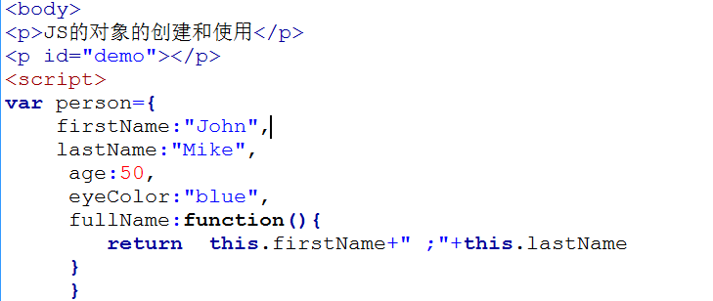

代码：

<!doctype html>

<html>

<head>

<meta charset="utf-8">

<title>无标题文档</title>

</head>

<body>

<p id="p1"></p>

<script>

var person ={

firstName:"John",

lastName:"Mike",

age:50,

eyeColor:"blue",

fullName:function(){

return this.firstName+" ;"+this.lastName;

}

}

alert(person.fullName());

document.getElementById("p1").innerHTML = person['age'];

document.write(person.firstName+"<br/>");

</script>

</body>

</html>

截图：

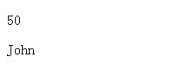

1. Date对象的使用
2. 完成date对象的创建，并输出

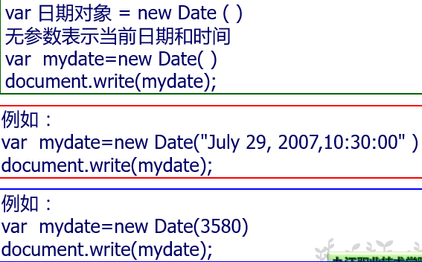

1. Date对象完成静态时钟的显示（显示当前的日期，包括年月日时分秒）
2. Date对象完成动态时钟的显示

1）2）3）

代码：

<!doctype html>

<html>

<head>

<meta charset="utf-8">

<title>无标题文档</title>

<script>

var mydate = new Date();

document.write("<p>"+mydate+"</p>");

var mydate2 = new Date("July 19,2007,10:30:00");

document.write("<p>"+mydate2+"</p>");

var mydate3 = new Date(5000);

document.write("<p>"+mydate3+"</p>");

//2

document.write("题目2静态时针");

var mydate4 = new Date();

var mt4 = mydate4.getMonth() +1;

var outstr1 = mydate4.getFullYear()+"年"+mt4+"月"+mydate4.getDate()+"日"+mydate4.getHours()+"时"+mydate4.getMinutes()+"分"+mydate4.getSeconds()+"秒"+"<br/>";

document.write("<p>"+outstr1+"</p>");

//3

document.write("题目3动态时针");

function dynamticda(){

var mydate5 = new Date();

var ys = mydate5.getFullYear();

var mts = mydate5.getMonth() + 1;

var dy = mydate5.getDate();

var hr = mydate5.getHours();

var mt = mydate5.getMinutes();

var sd = mydate5.getSeconds();

var outstr2 = ys+"年"+mts+"月"+dy+"日"+hr+"时"+mt+"分"+sd+"秒";

document.getElementById("pid1").innerHTML = outstr2;

}

setInterval("dynamticda()",1000);

</script>

</head>

<body>

<p id="pid1"></p>

</body>

</html>

截图：

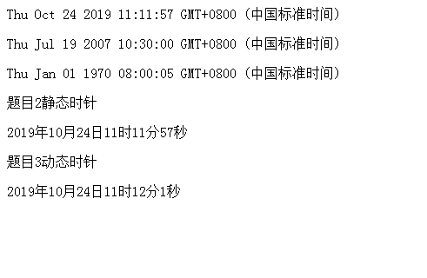

1. 选做：教程P103页案例，年历的制作

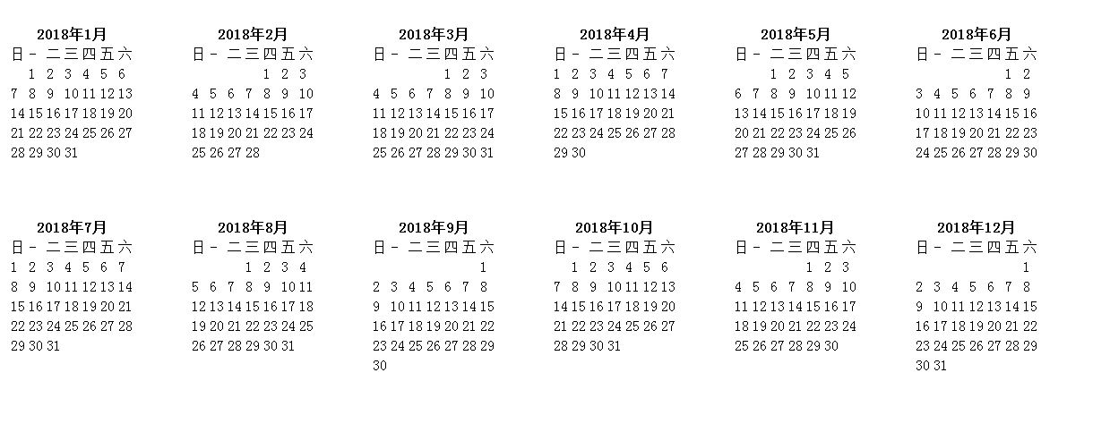

代码：

<!doctype html>

<html>

<head>

<meta charset="utf-8">

<title>无标题文档</title>

<style>

table{

float:left;

margin:30px;

}

</style>

<script>

var year = parseInt(prompt("请输入年份"));

function calendar(y){

var w = new Date(y,0).getDay();

var htmls = '';

for(var m = 1; m <= 12; m++){

htmls += '<table>';

htmls += '<tr><th colspan="7">'+y+'年'+m+'月</th></tr>';

htmls += '<tr><td>日</td><td>-</td><td>二</td><td>三</td><td>四</td><td>五</td><td>六</td></tr>';

var max = new Date(y,m,0).getDate();

htmls +='<tr>'

for(var d = 1; d <= max; ++d){

if(w && d == 1){

htmls += '<td colspan="'+w+'"></td>';

}

htmls += '<td>'+d+'</td>';

if(w==6&&d!=max){

htmls += '</tr><tr>';

}else if(d == max){

htmls += '</tr>';

}

w = (w +1>6)?0:w+1;

}

htmls += '</table>';

}

return htmls;

}

document.write(calendar(year));

</script>

</head>

<body>

</body>

</html>